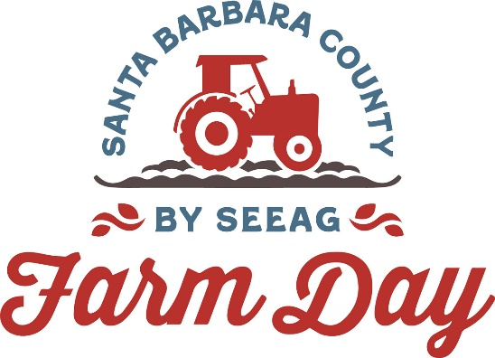

Contacts:
Mary Maranville
Students for Eco-Education and Agriculture (SEEAG)
805-892-8155
Mary@seeag.org

Diane Rumbaugh
805-493-2877
diane@rumbaughpr.com

Fifth Annual Santa Barbara County Farm Day Attracts Over 5,000

Santa Maria, Calif. (Date)--The fifth annual Santa Barbara County Farm Day, a once-a-year opportunity to show the public how our food is grown, attracted over 5,000 community members. Farm Day, which took place September 23, included behind-the-scenes tours, tastings, giveaways and kid-friendly activities. Participating farms and agricultural organizations were in Santa Maria, Santa Ynez Valley, Orcutt and Los Alamos.

“Farm Day is a fun, free way to spend a day on multiple farms,” says Mary Maranville, founder and CEO of Farm Day organizer Students for Eco-Education and Agriculture (SEEAG). “All ages who attended Farm Day came away with a better appreciation of where our food comes from and the people who make it all happen.”

Members of the public from throughout the central coast had the opportunity to select farms and ag organizations to visit from a list of 17 locations.

“Our Central Coast agricultural sector feeds the nation and serves as a backbone for our regional economy,” says Assemblyman Gregg Hart. “I am grateful for SEEAG’s work to educate students and the community at large about our local agricultural industry. The education provided by SEEAG connects our community members and farmers, shines a spotlight on the origin of our fruits and vegetables, and teaches lifelong lessons to students.”

SEEAG’s Ventura County Farm Day is coming up on November 4. For more information about Ventura County Farm Day, visit https://venturacountyfarmday.com or call 805-892-8155.
###

