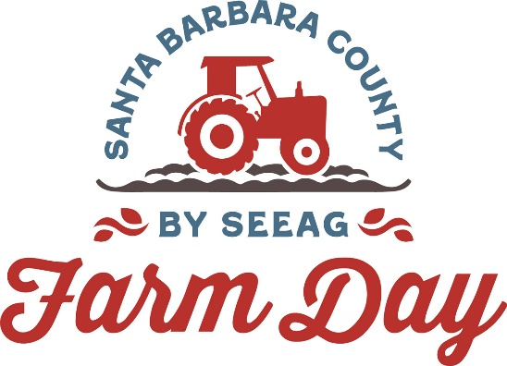

Contacts:
Mary Maranville
Students for Eco-Education and Agriculture (SEEAG)
805-892-8155
Mary@seeag.org

Diane Rumbaugh
805-493-2877
diane@rumbaughpr.com

Santa Barbara County Farm Day Viticulture Hub Features Vineyard Tours;
Free Wine Tasting

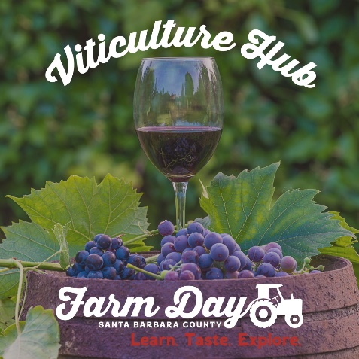
Santa Maria, Calif. (September 18, 2023)--The fifth annual Santa Barbara County Farm Day on Saturday, September 23 includes vineyard/winemaking tours and free wine tasting at the Farm Day Viticulture Hub located at Allan Hancock College Student Farm and Vineyard in Santa Maria (corner of East Park Avenue and South College Drive at John Osborne Field, Parking Lot 12).

“Since the vineyard is also a teaching location, Farm Day participants will have the rare opportunity to take tours of the vineyard,” says Mary Maranville, founder and CEO of Students for Eco-Education and Agriculture (SEEAG), a 501(c)3 nonprofit organization which puts on Farm Day. “Normally the vineyards are not open to the public.”

Riverbench Vineyards & Winery, Allan Hancock College Winery and wineries represented by Coastal Vineyard Care will hold free wine tastings. Visitors will also hear from vintners about the latest technology that goes into winemaking as well as traditional processes.

Next to the Viticulture Hub is the traditional Farm Day Hub with its free produce, ag tours and kids’ activities. The Santa Barbara Ag Commissioner’s office will have its trained dogs onsite demonstrating how they sniff out crop-related pests and diseases as well as fruit illegally entering the county.

“The Farm Day Hub is a good way to start or end the Farm Day experience,” says Maranville.

With the help of an online Farm Day Trail Map, the public can pick which of the 17 farms and farm-related organizations to visit on Farm Day. Farms are in Santa Maria, Santa Ynez Valley, Orcutt and Los Alamos.

Farm Day is free to attend. Tour hours are from 10 a.m. to 3 p.m. Preregistration is suggested. All those attending the Viticulture Hub must preregister and be at least 21 years of age.

To register, go to My805Tix (https://my805tix.com/e/sbfarmday). Once registered, visitors show their 805Tix QR code at each location to enter without having to sign in. They are also automatically included in a drawing to win prizes.

Santa Barbara County Farm Day sponsors include The Wood-Claeyssens Foundation, Allan Hancock College, Edwin and Jeanne Woods Family Foundation, Santa Barbara Foundation, Driscoll’s, AgWest Farm Credit, Legacy Growers, Sakata, Central West Produce, Plantel Nurseries, Bonipak and Reiter Affiliated Companies.

For more information about Santa Barbara County Farm Day, visit www.SantaBarbaraCountyFarmDay.com or call 805-892-8155. No pets allowed.
###

