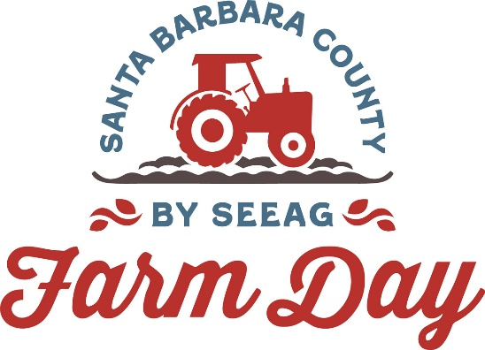

Contacts:
Mary Maranville
Founder/CEO
Students for Eco-Education and Agriculture (SEEAG)
805-892-8155
mary@seeag.org

Diane Rumbaugh
805-493-2877
diane@RumbaughPR.com

2023 Santa Barbara County Farm Day Seeks Sponsors

Santa Maria, Calif. (July 13, 2023)-- Sponsors are being sought for the 5th Annual Santa Barbara County Farm Day taking place Saturday, September 23. On Farm Day, over 10 Santa Barbara County farms, ranches and agricultural organizations open their doors and invite the public to experience a day of free agricultural activities, tastings and tours.

Santa Barbara Farm Day is presented by Students for Eco-Education and Agriculture (SEEAG), a 501(c)3 nonprofit organization that provides cost-free agricultural education programs about the importance of farming and farm-fresh foods in Santa Barbara and Ventura counties.

"By sponsoring Santa Barbara County Farm Day, individuals and businesses help connect and educate the community about local agriculture and the food supply chain," says Mary Maranville, SEEAG’s founder and CEO. "Farm Day is also a way to say thank you to the men and women who grow the food we eat every day.”

Santa Barbara County Farm Day sponsors already participating include Wood Clayessens Foundation, Edwin & Jeanne Woods Family Foundation, Santa Barbara Foundation, AgWest Farm Credit, Bonipak/Betteravia, Cal Giant, Central West Produce, Legacy Growers LLC, Plantel Nursery (in part with Waldron Family Trust) and Sakata.
Last year, Santa Barbara Farm Day attracted over 5,000 attendees. Sponsorships are available at various levels. Individuals and businesses interested in supporting the event can find more information at https://santabarbaracountyfarmday.com/support or by calling 805-892-8155.

###
About SEEAG
Founded in 2008, Students for Eco-Education and Agriculture (SEEAG) is a 501(c)3 nonprofit organization that aims to help young students understand the origins of their food by bridging the gap between agriculture and consumption through its agricultural education programming. SEEAG’s “The Farm Lab” program teaches schoolchildren about the origins of their food and

the importance of local farmland by providing schools with classroom agricultural education and free field trips to farms. Through this and other SEEAG programs, over 100,000 elementary school students in Central and Southern California have increased their understanding of the food journey. For more information, visit www.seeag.org or email Mary Maranville at mary@seeag.org.

