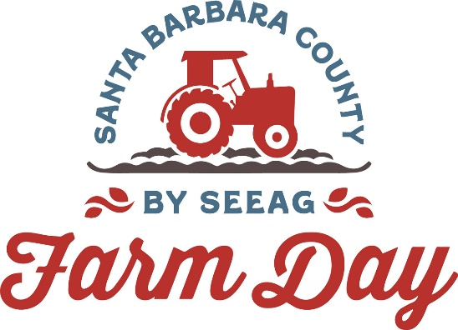

Contacts:
Mary Maranville
Students for Eco-Education and Agriculture (SEEAG)
805-892-8155
Mary@seeag.org

Diane Rumbaugh
805-493-2877
diane@rumbaughpr.com

Fifth Annual Santa Barbara County Farm Day – Meet The Hands That Feed You

Santa Maria, Calif. (August 15, 2023)--The fifth annual Santa Barbara County Farm Day, a once-a-year opportunity to experience how our food is grown, is set for Saturday, September 23. The day includes behind-the-scenes tours, tractor/trailer rides, tastings, giveaways and kid-friendly activities. With the help of the online Farm Day Trail Map, the public can pick which farms to visit and then map out the day’s driving itinerary. Farms are in Santa Maria, Santa Ynez Valley, Orcutt and Los Alamos.

"Farm Day is the highlight of our year, where our employees and harvesters take center stage as educators,” says Martin Cossio, ranch manager at Betteravia Farms/Bonipak Produce, a Farm Day participating farm. “In today’s world, agriculture is advancing rapidly as our demand for food production increases. The people we get to work alongside every day are vitally important to our success. Thanks to their commitment and dedication, we are able to get our freshly grown products from our fields directly to stores.”

Farm Day is free to attend. Tour hours are from 10 a.m. to 3 p.m. Attendees can tour farms that produce specialty crops, seasonal produce and berries, wine grapes and livestock. New this year is a Farm Day Hub at Allan Hancock’s Student Learning Garden & Vineyard. It will feature displays, kids' projects, vegetable garden tours and produce giveaways.

The Farm Day Hub will include a viticulture section where Riverbench Vineyards & Winery, Allan Hancock College Winery and wineries represented by Coastal Vinyard Care will hold free wine tastings. Visitors will also meet winemakers, learn about the agricultural side of winemaking and take vineyard tours.

Santa Barbara County Farm Day is organized by the 501c3 nonprofit Students for Eco-Education and Agriculture (SEEAG). SEEAG’s mission is to educate students and the greater community about the farm origins of our food and agriculture's contribution to our nutritional well-being.

“The journey of a piece of fruit or vegetable from seed to market is one we often take for granted,” says Mary Maranville, SEEAG founder and CEO. “It involves the hard work of literally hundreds of people to see that we always have an abundance of fresh produce to choose from.”

The public can avoid entry lines at each venue by registering in advance at My805Tix (https://my805tix.com/e/sbfarmday). Once registered, visitors show their 805Tix QR code at each location to enter without having to sign in. Plus, they are automatically included in a drawing to win prizes. Winners will be notified on Farm Day.

Santa Barbara County Farm Day sponsors include The Wood-Claeyssens Foundation, Allan Hancock College, Edwin and Jeanne Woods Family Foundation, Santa Barbara Foundation, Driscoll’s, AgWest Farm Credit, Legacy Growers, Sakata, Central West Produce, Plantel Nurseries, Bonipak and Reiter Affiliated Companies.

For more information about Santa Barbara County Farm Day, visit www.SantaBarbaraCountyFarmDay.com or call 805-892-8155. Check the Farm Day website and social media for the latest list of farm participants. No pets allowed. Also, mark your calendars for the 11th annual Ventura County Farm Day on November 4.
###

